Statistics - Worksheet B

1 Consider the given data set:

6 5 12 7 2 10 5 8 23 9 18 7 4

a List the data in order, from smallest to largest.

________________________________________________________________

b For the data find:

i the minimum and maximum values ___________________________

ii the range ___________________________

iii the mode ___________________________

iv the mean, correct to one decimal place ___________________________

v the median (Q₂) ___________________________

vi the lower and upper quartiles ___________________________
(Q₁ and Q₃)

vii the interquartile range (IQR) ___________________________

viii any outliers ___________________________

c Draw a boxplot to summarise the data, marking outliers if they exist.

2 The average monthly maximum temperature for an Australian city is recorded over
12 months.

Month | J | F | M | A | M | J | J | A | S | O | N | D
Temperature (°C) | 35.0 | 33.5 | 28.5 | 25.0 | 19.5 | 16.5 | 16.0 | 18.5 | 20.0 | 26.0 | 28.0 | 32.5

a Plot the time series.

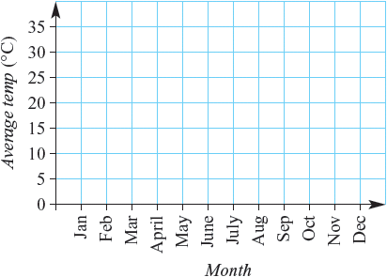

b Describe the trend in the data over the 12 months.

_____________________________________________________________________

_____________________________________________________________________

_____________________________________________________________________

_____________________________________________________________________

3 Consider the variables x and y and the corresponding bivariate data.

x | 1 | 2 | 3 | 4 | 5 | 6 | 7 | 8
y | 7 | 6 | 1 | 4 | 5 | 3 | 3 | 2

a Draw a scatter plot for the data.

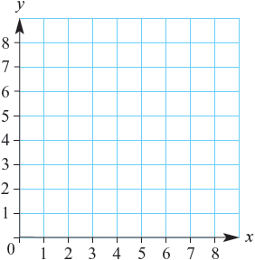

b Is there positive, negative or no correlation between x and y?

______________________________________________________________________

c Is the correlation between x and y strong or weak?

______________________________________________________________________

d Identify any outliers.

______________________________________________________________________

e Fit a line of best fit by eye to the data on the scatter plot.

f Use your line of best fit to estimate:

i y when x = 2.5 ______________________________________________

ii y when x = 0 ______________________________________________

iii x when y = 1.5 ______________________________________________

iv x when y = 5.5 ______________________________________________

